Coming from direction Bratislava on the R1 highway:

- Turn right to the 50 - E58 direction Zvolen / Sahy / Košice
- In Zvolen at the traffic lights you turn right to the 66 – E77 direction Sahy.
- Follow this road through the villages Podzámčok and Dobrá Niva
- After Dobrá Niva turn left to the 527 direction Sása / Velký Krtiš

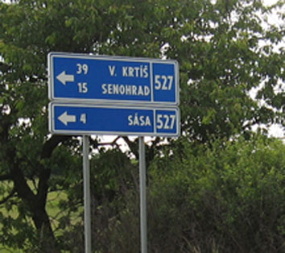

- Stay on road 527 direction Velký Krtiš
This road leads you around the village Pliešovce.
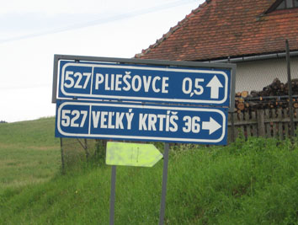
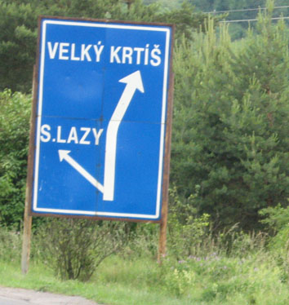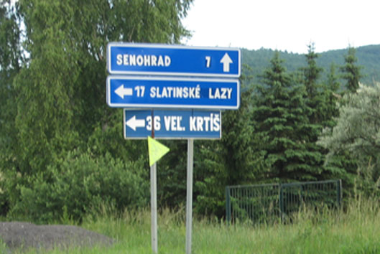

- Then turn left direction Slatinské Lazy

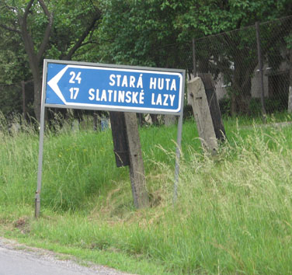

- Now you enter the small village Zabavá. Turn left direction Slatinske Lazy.

- Follow this beautiful winding road until you see the sign “Víta vás Zaježová” at the crossing. On your right you see a bus stop and wooden sign post.
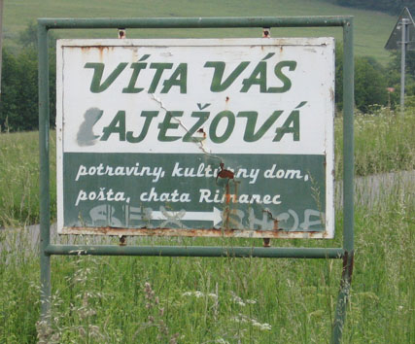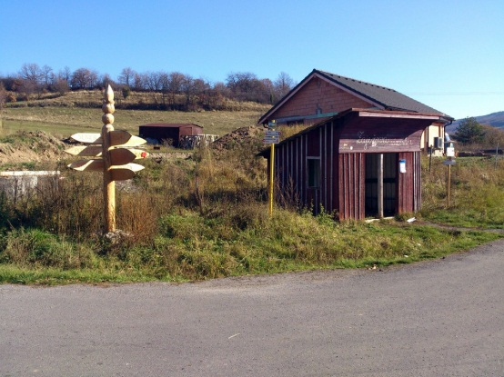

- Here you turn left. (direction Sekier and Kralova)
- You pass a farm on the left side of the road. (Don’t turn right here!)
- Then the road turns right.
- Now you can already see Lastovička on the left side of the road.
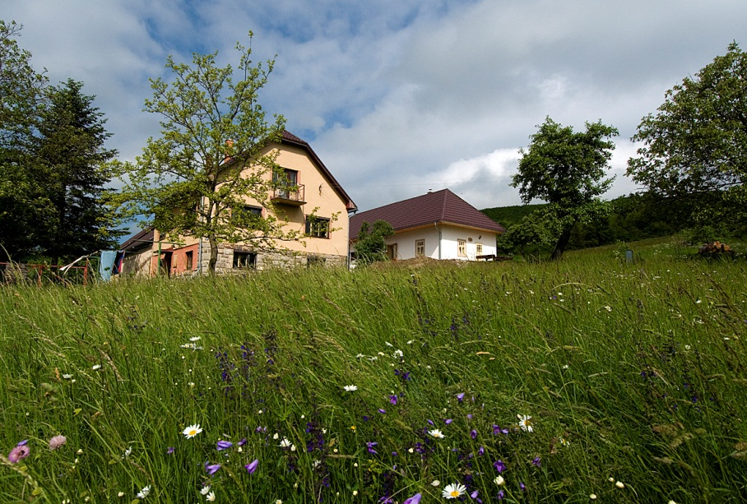

- Turn left and keep on going on this little road through the field.

- At the end of this road you turn left.

- Pass the neighbours house situated next to the right side of the road.

- Now you arrive at holiday house Lastovička, welcome.



